**WHITTAKER SHANON INTERPOLATOR**

ARKADEEP MUKHERJEE 17BEC1001

DEBARPAN MAZUMDER 17BEC1002

ABHINAV BHATTACHARYA 17BEC1003

SUBHRA MONDAL 17BEC1146

WHEN INPUT SIGNAL IS IN THE FORM OF AN EXPRESSION:

clc

clear all

syms t s

F = 1000;

Fs = 50;

T = 1/Fs;

t = 0:1/F:1;

ts = 0:T:1;

x = @(t)(3*sin(2*pi*18*t) + cos(2*pi*6*t));

xn = x(ts) ;

interpolated = 0;

for n=1:length(ts)

interpolated = interpolated + xn(n)*sinc(t/T-(n-1));

end

hold off;

plot(t, x(t), 'b', 'linewidth', 3);

hold on;

stem(ts, xn); hold on;

plot(t, interpolated, 'k-.');

figure();

h=sinc(t/T);

plot(h);

fth=fft(h);

figure()

plot(fth);

1.

X(t)=(3*sin(2*pi*18*t) + cos(2*pi*6*t));

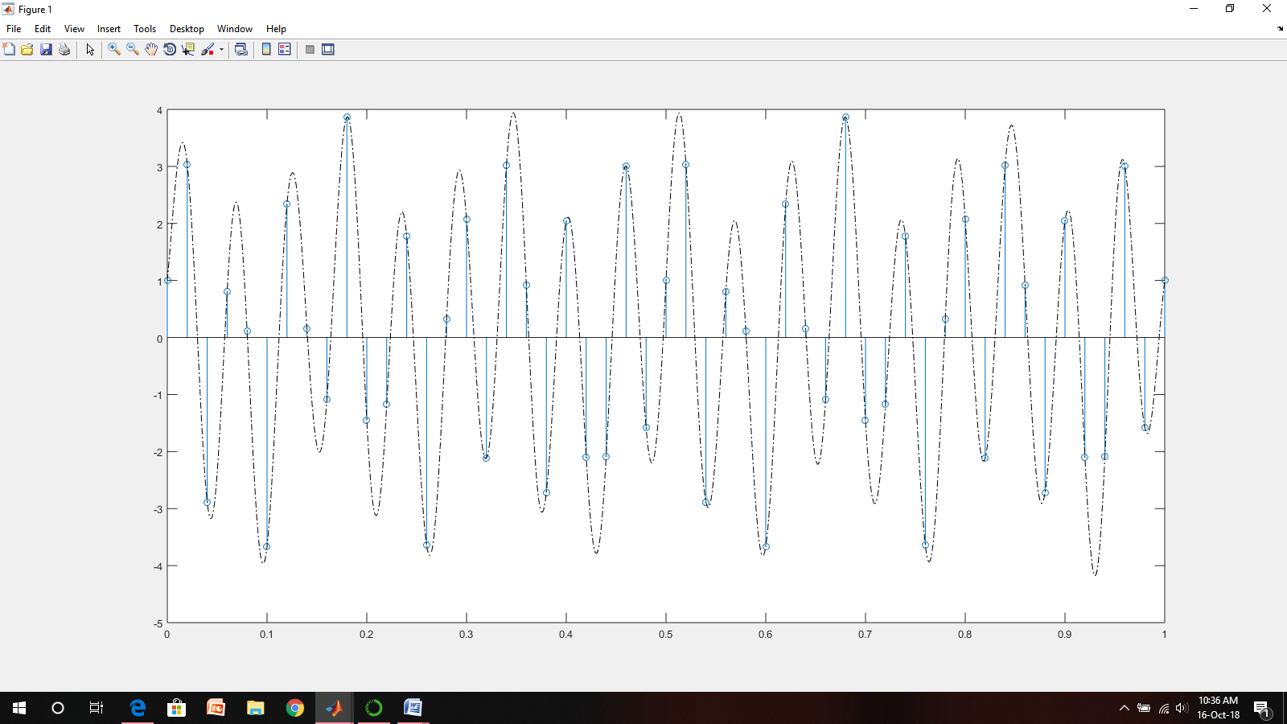

WHEN INPUT SIGNAL IS IN THE FORM OF A SET OF REAL NUMBERS

clear all

syms t f

x=input('Enter set of numbers ');

F=input('Enter sampling frequency ');

T=1/F;

m=0;

for n=1:length(x)

m=m+x(n)*sinc((t-(n*T))/T);

end

m

stem(x)

hold on;

ezplot(m)

fto=fourier(m,t,f)

fti=fft(x)

figure()

ezplot(real(fto))

disp('causal')

b=isstable(m);

if(b==1)

disp('stable');

else

disp('non stable');

end

x1=input('Enter the value of x1: ');

x2=input('Enter the value of x2: ');

y1=subs(m,t,x1);

y2=subs(m,t,x2);

a=input('Enter the value of a: ');

b=input('Enter the value of b: ');

sum1=a*x1+b*x2;

y3=subs(m,t,sum1);

if(y3==y1+y2)

disp('Linearity is True');

else

disp('Linearity is not True');

end

disp('Check for time invariance ')

T=input('Shifting value as T: ');

ans=subs(m,t,t+T);

figure()

ezplot(m)

hold on;

ezplot(ans)

COMMAND WINDOW OUTPUT

1.

Enter set of numbers [1 2 3 4 5]

Enter sampling frequency 2

m =

sin(pi*(t - 1))/(pi*(t - 1)) + (2*sin(pi*(t - 2)))/(pi*(t - 2)) + (3*sin(pi*(t - 3)))/(pi*(t - 3)) + (4*sin(pi*(t - 4)))/(pi*(t - 4)) + (5*sin(pi*(t - 5)))/(pi*(t - 5))

fto =

- (pi*heaviside(- pi - f)*exp(-f*1i) - pi*exp(-f*1i)*heaviside(pi - f))/pi - (2*(pi*heaviside(- pi - f)*exp(-f*2i) - pi*exp(-f*2i)*heaviside(pi - f)))/pi - (3*(pi*heaviside(- pi - f)*exp(-f*3i) - pi*exp(-f*3i)*heaviside(pi - f)))/pi - (4*(pi*heaviside(- pi - f)*exp(-f*4i) - pi*exp(-f*4i)*heaviside(pi - f)))/pi - (5*(pi*heaviside(- pi - f)*exp(-f*5i) - pi*exp(-f*5i)*heaviside(pi - f)))/pi

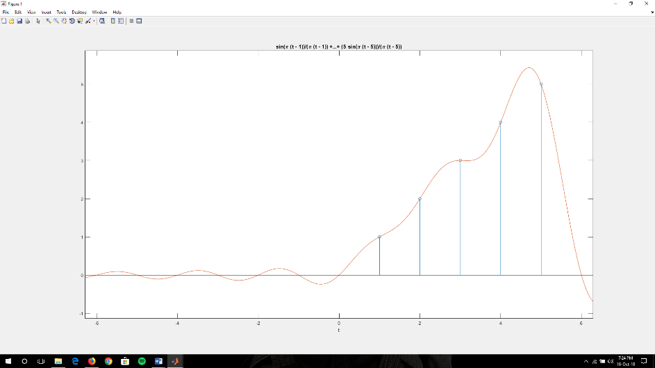

fti =

15.0000 + 0.0000i -2.5000 + 3.4410i -2.5000 + 0.8123i -2.5000 - 0.8123i -2.5000 - 3.4410i

causal

stable

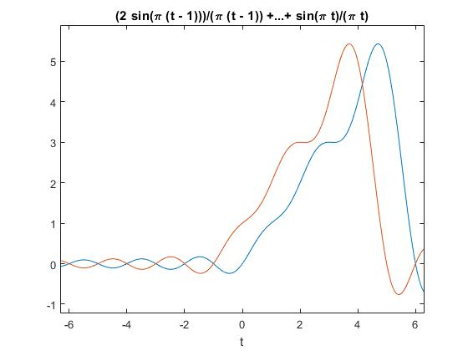Enter the value of x1: 8

Enter the value of x2: 8

Enter the value of a: 1

Enter the value of b: 1

Linearity is True

Check for time invariance

Shifting value as T: 1

Therefore, time variant

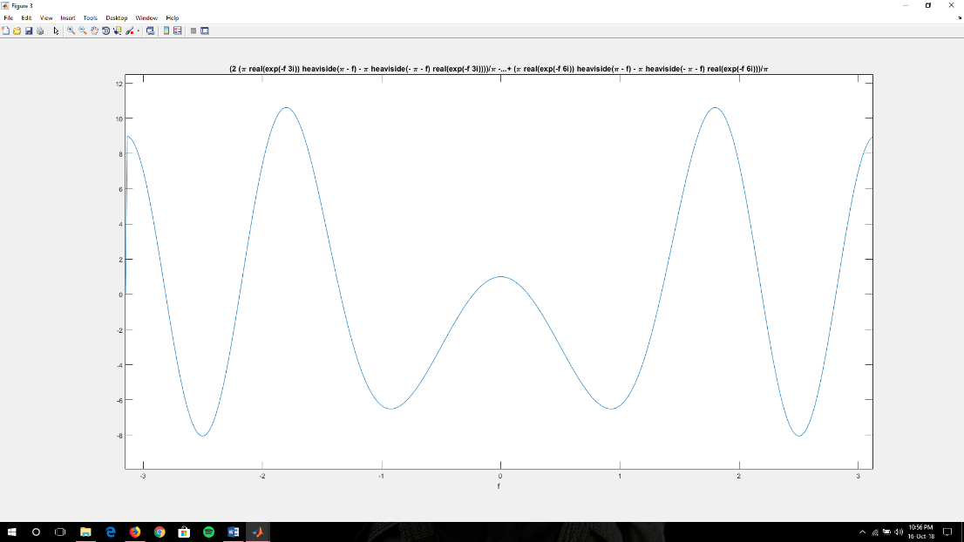

Output in frequency domain

**2.**

Enter set of numbers [1,-2,-3,1,4,8]

Enter sampling frequency 2

m =

sin(pi*(t - 1))/(pi*(t - 1)) - (2*sin(pi*(t - 2)))/(pi*(t - 2)) - (3*sin(pi*(t - 3)))/(pi*(t - 3)) + sin(pi*(t - 4))/(pi*(t - 4)) + (4*sin(pi*(t - 5)))/(pi*(t - 5)) + (8*sin(pi*(t - 6)))/(pi*(t - 6))

fto =

- (pi*heaviside(- pi - f)*exp(-f*1i) - pi*exp(-f*1i)*heaviside(pi - f))/pi + (2*(pi*heaviside(- pi - f)*exp(-f*2i) - pi*exp(-f*2i)*heaviside(pi - f)))/pi + (3*(pi*heaviside(- pi - f)*exp(-f*3i) - pi*exp(-f*3i)*heaviside(pi - f)))/pi - (pi*heaviside(- pi - f)*exp(-f*4i) - pi*exp(-f*4i)*heaviside(pi - f))/pi - (4*(pi*heaviside(- pi - f)*exp(-f*5i) - pi*exp(-f*5i)*heaviside(pi - f)))/pi - (8*(pi*heaviside(- pi - f)*exp(-f*6i) - pi*exp(-f*6i)*heaviside(pi - f)))/pi

fti =

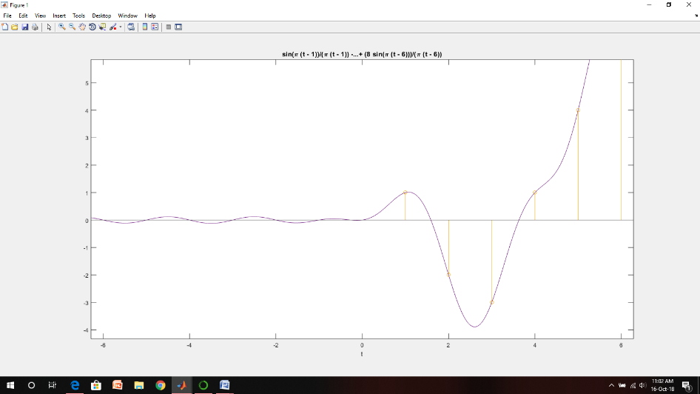 9.0000 + 0.0000i 2.5000 +14.7224i -1.5000 + 2.5981i -5.0000 + 0.0000i -1.5000 - 2.5981i 2.5000 -14.7224i

causal

stable

Enter the value of x1: 8

Enter the value of x2: 8

Enter the value of a: 1

Enter the value of b: 1

Linearity is True

Check for time invariance

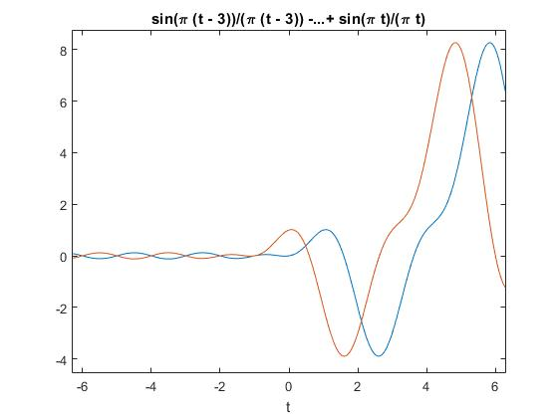Shifting value as T: 1

Therefore time variant

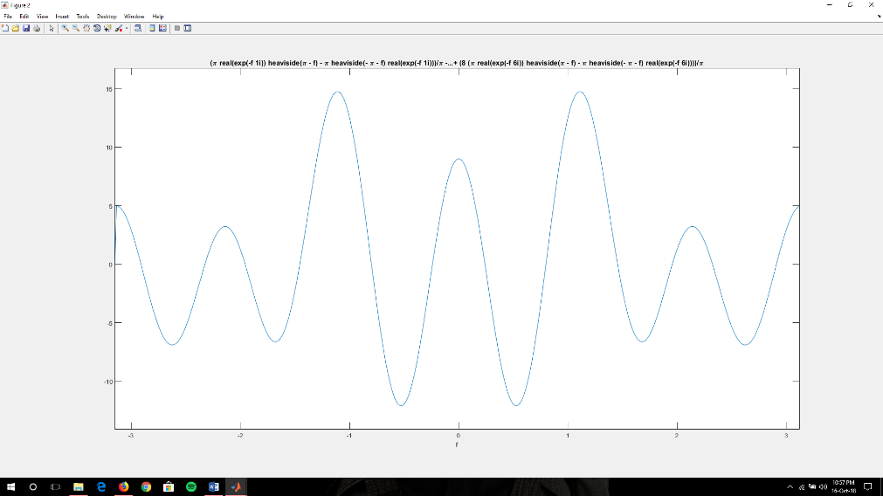

Output in frequency domain

**3.**

Enter set of numbers [-2,-2,2,6,-4,1]

Enter sampling frequency 4

m =

(2*sin(pi*(t - 3)))/(pi*(t - 3)) - (2*sin(pi*(t - 2)))/(pi*(t - 2)) - (2*sin(pi*(t - 1)))/(pi*(t - 1)) + (6*sin(pi*(t - 4)))/(pi*(t - 4)) - (4*sin(pi*(t - 5)))/(pi*(t - 5)) + sin(pi*(t - 6))/(pi*(t - 6))

fto =

(2*(pi*heaviside(- pi - f)*exp(-f*1i) - pi*exp(-f*1i)*heaviside(pi - f)))/pi + (2*(pi*heaviside(- pi - f)*exp(-f*2i) - pi*exp(-f*2i)*heaviside(pi - f)))/pi - (2*(pi*heaviside(- pi - f)*exp(-f*3i) - pi*exp(-f*3i)*heaviside(pi - f)))/pi - (6*(pi*heaviside(- pi - f)*exp(-f*4i) - pi*exp(-f*4i)*heaviside(pi - f)))/pi + (4*(pi*heaviside(- pi - f)*exp(-f*5i) - pi*exp(-f*5i)*heaviside(pi - f)))/pi - (pi*heaviside(- pi - f)*exp(-f*6i) - pi*exp(-f*6i)*heaviside(pi - f))/pi

fti =

1.0000 + 0.0000i -7.5000 - 2.5981i 5.5000 + 7.7942i -9.0000 + 0.0000i 5.5000 - 7.7942i -7.5000 + 2.5981i

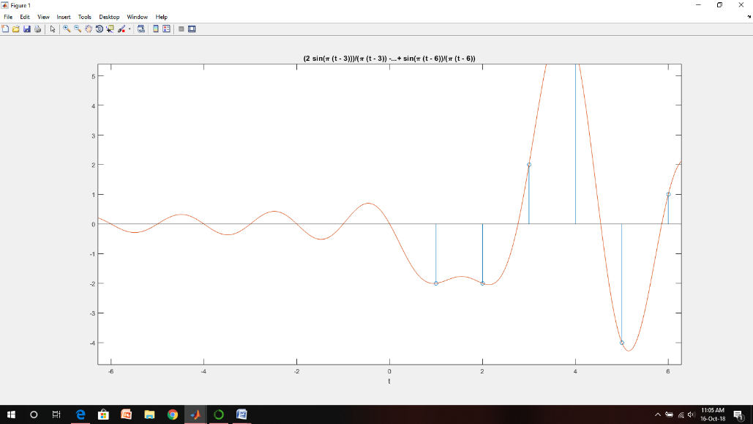

causal

stable

Enter the value of x1: 8

Enter the value of x2: 8

Enter the value of a: 1

Enter the value of b: 1

Linearity is True

Check for time invariance

Shifting value as T: 1

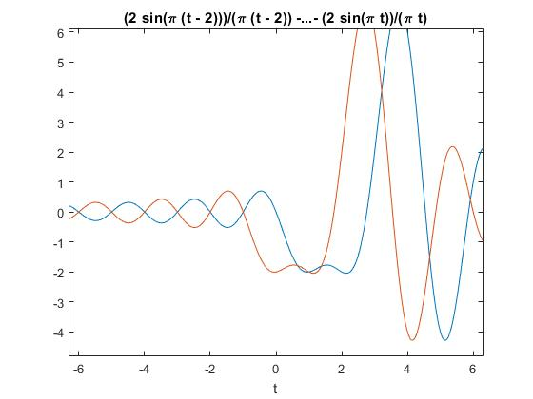Therefore time variant

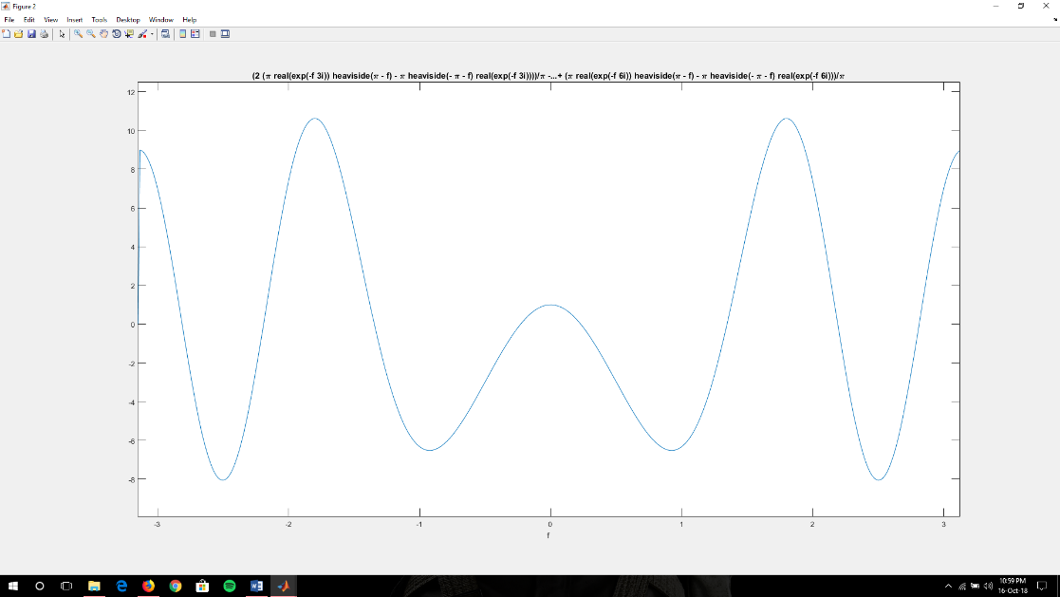

Output in frequency domain

Impulse response:

h(t)=sinc(t/T)

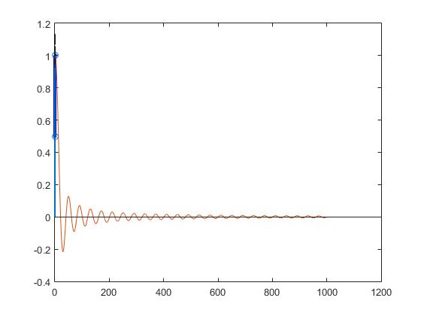

Transfer function plot (Fourier Transform for h(t) in frequency domain)

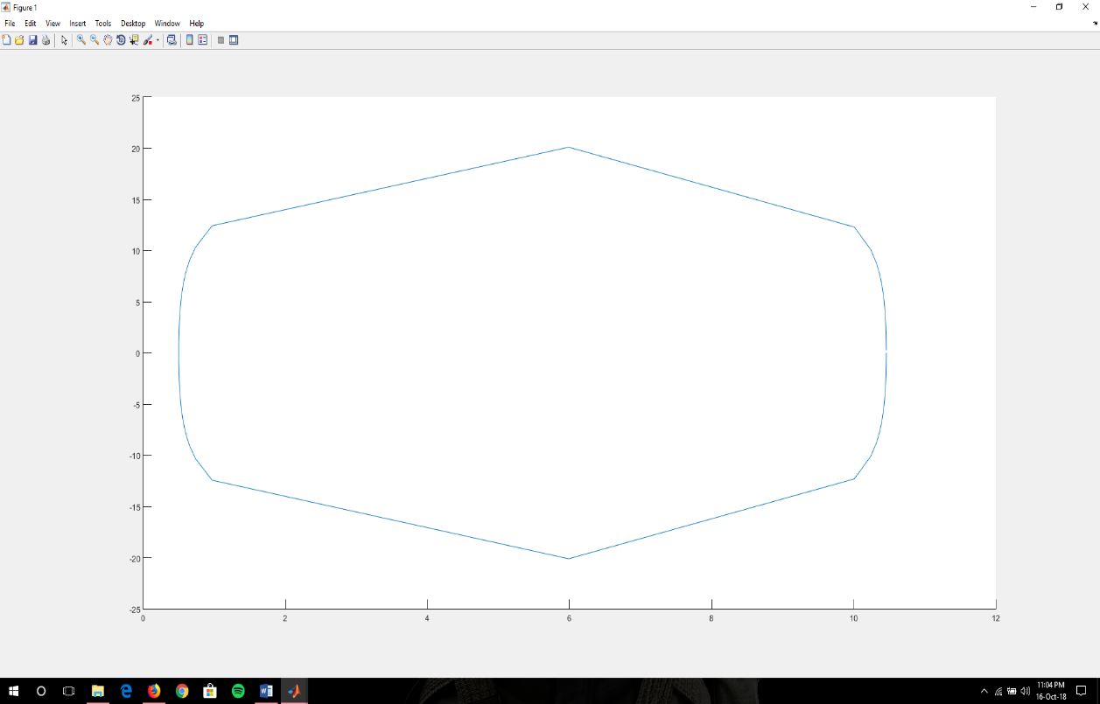

**OUTPUT OF BASIC SIGNALS**

1. INPUT: u(t)

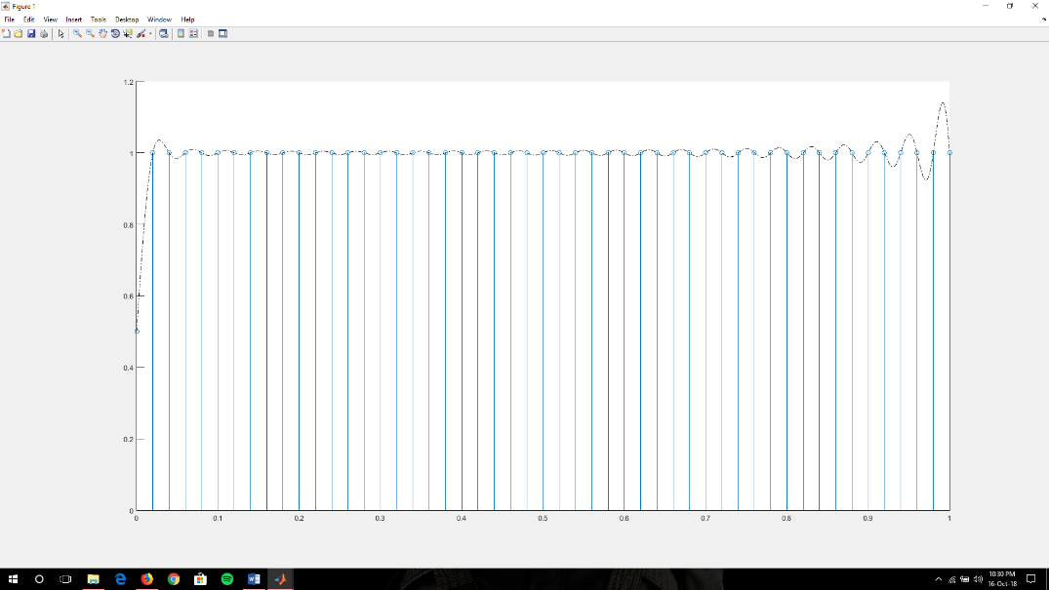

2. INPUT: r(t)

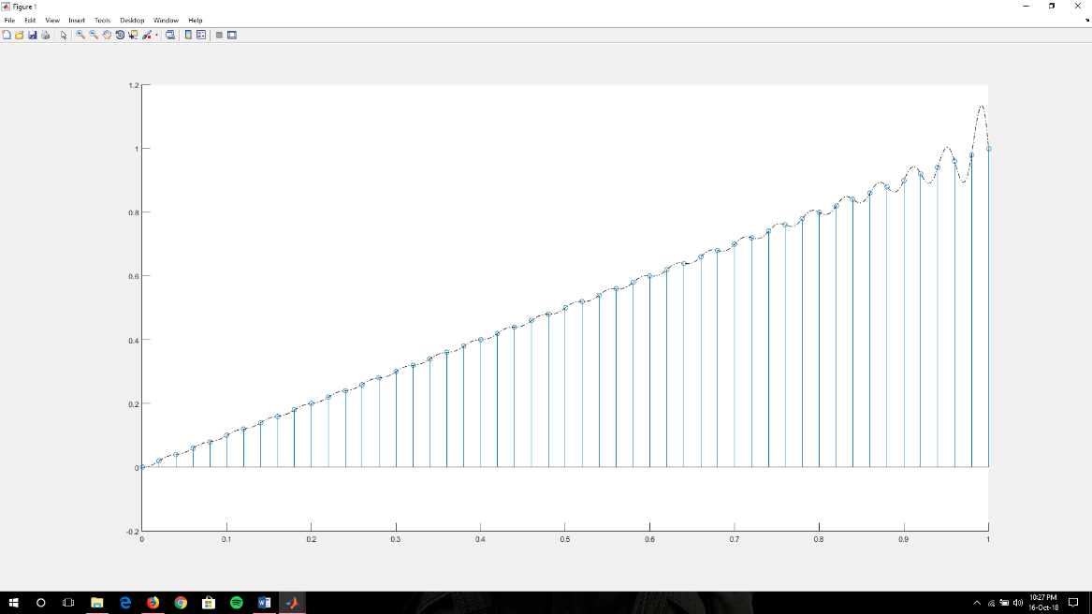

4. INPUT: exp(-3*t)

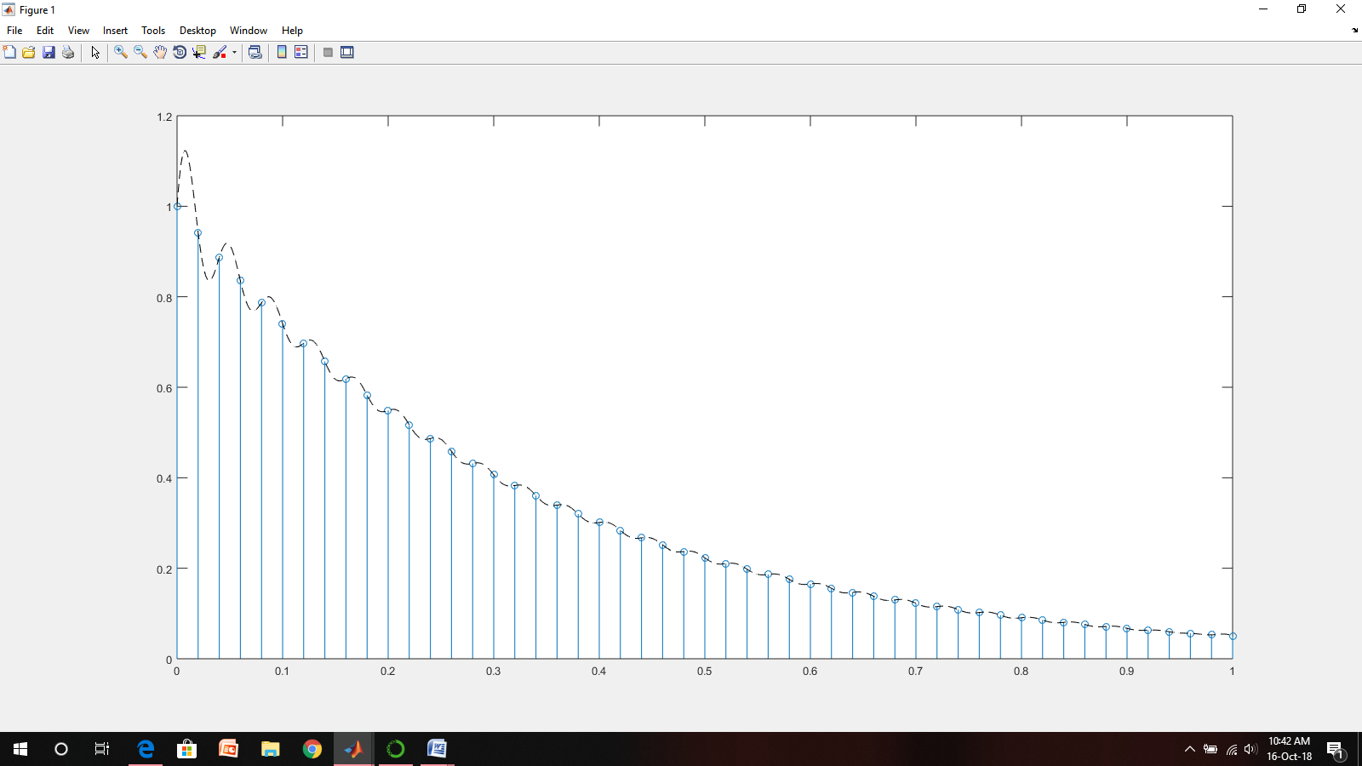

5. INPUT: exp(3*t)

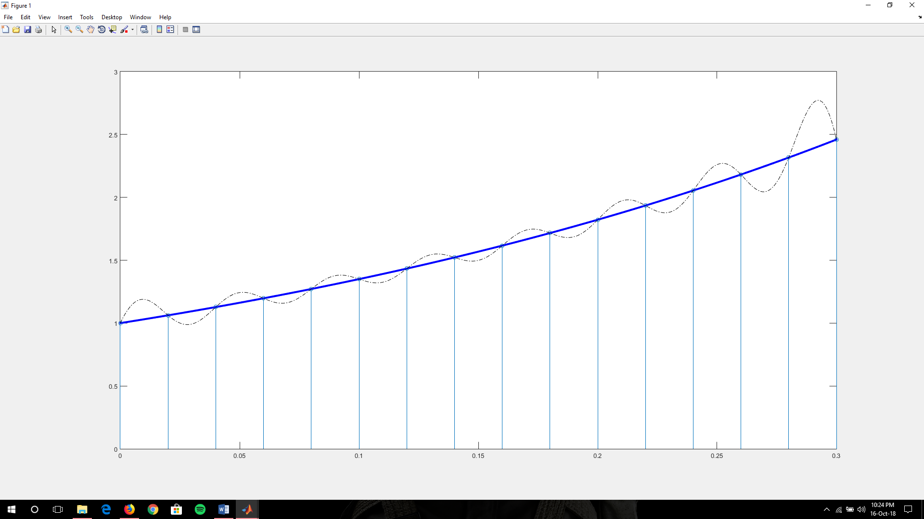

6. INPUT: UNIT IMPULSE dirac(t)

